The Report of assignment 4

|  |  |
| --- | --- |
| Group members | |
| Name: | Weizhou.Wen |
| ID | 1716609 |
| Name |  |
| ID |  |
| Name |  |
| ID |  |
| Name |  |
| ID |  |

The 12ed group

Project A

Table of content

Specifications 2

Overall spec. 2

Customer spec. 2

System spec. 2

Analysis and Design 2

Input 3

Output 3

Data structure 3

Algorithm 3

Design: 3

Implementation 5

Testing 5

Bugs report 5

User manual 5

Specifications

Overall spec.

The program is designed for the administrator of library, the student of class, the staff of university. The program should help the administrator to manage the data. Help staff and student to reserve book, borrow book and return book. Every user of the three kinds all need to log in their account to use the program.

Customer spec.

Library administrator:

The administrator should be capable to manage the information of book and other users. The operation include browse, add, update, delete, search and display. All the information will be stored into a binary file. Then, the program can also calculate the fine of users if their books are expired. The administrators are able to clear the fine if the user has paid the money.

Student:

The student should be capable to use the program to deal the business with book, including reserving book, borrow book, check expiration date of book and return book. The program should also can tell the student what book he/she has reserved and borrowed. The student can reserve 3 books at most. Student can borrow 6 books for 6 months at most. If their book is expired, they will be fined for $1/day/book.

Staff:

The staff also should be capable to use the program to deal the business with book, including reserving book, borrow book, check expiration date of book and return book. The program should also can tell the staff what book he/she has reserved and borrowed. The staff can reserve 3 books at most. Student can borrow 50 books for 3 years at most. If their book is expired, they also will be fined for $1/day/book.

System spec.

The program should include 5 class. One for administrator. one for book. One class is designed for user. One class is designed for student. The last one is designed for staff. Moreover, class “student” and “staff” are the derived class of the class “user”.

The program should store the information into different file.

The file ”administrator” stores the information of administrator account.

File “user”, “staff” and “student” stores the information of user’s account.

File “book” stores the information of book.

Analysis and Design

Input

When the program starts to run, users need to input characters to determine the user's identity or exit the program. When the users identified by the system are employees or students, the system enters the account login/registration interface. After system identification, the system enters the selection interface. Users can choose borrowing books, returning books, checking dates, booking books and inquiring books through the system. When the system identifies users as administrators, administrators need to input characters to log in/create accounts or return. After the system judges, administrators can manage users and books. Administrators can search, browse, update, add or delete books, and also search, add, delete, update users ‘accounts and clear the fine. Users can search and borrow books by entering their names or numbers.

Output

At the beginning of the program, the system name and operation hints will be displayed on the screen. Users will get different privileges according to different input options. When the user is a student or employee, the system will give the user the option of login or create an account and return to the previous interface. When creating an account, the system will display the input account name, password and code. When all steps are input correctly, the system prompts the user to re-enter the account if the creation is successful and the input is incorrect. After successful login, the system will show users six choices, users can operate through the system. Students can borrow 3 books and employees can borrow 50 books. When the number of books borrowed by users reaches the maximum, the system will prompt users to borrow the maximum number. When the book has been borrowed, the system will prompt the user when he searches for it. When the user reserves books, the book has been reserved, and the system will prompt the user to reserve books when the user searches. When the user is the administrator, the system will give the administrator three options, book information management, user information management and return to the previous interface. Administrators can browse all users and Book information, input new information to the system, delete existing information in the system, update information in the system, and search for information. The system will output the desired results according to the user's operation.

Data structure

The functions used in this program：class, Subclass, judgment functions, clear screen functions, bool functions, for loop, switch function, custom functions and pointers.

Algorithm

This program uses cyclic statement algorithm, algebraic algorithm and pointer algorithm.

Design:

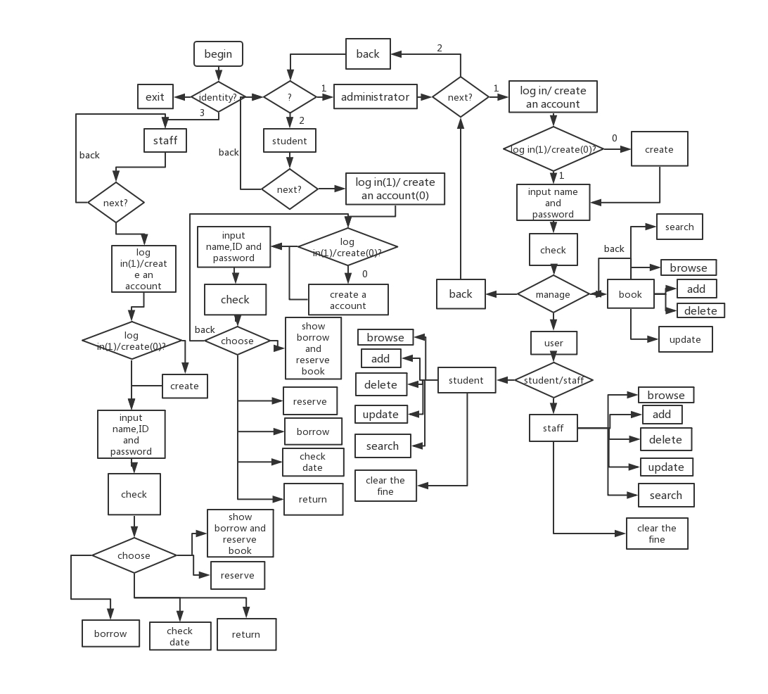

1. First, the program will question the identity of the customer.
2. If the customer is a student. The program will build a student class for him. In the student class, there are five attributes, including ID, name, fine, numOfbook, numOfbook_reserve.
3. In the class “staff”, there are also same five attributes.
4. Class ”staff” and class ”student” are the derive class of class “user”. In the class “user”, there are some function for check and set the five attributes, including”get_ID”,”get_name”,”get_fine”,”get_numOfbook”,”get_numOfbook_reserve”, “set_numOfbook_reserve”, “set_ID”, “set_name”, “set_fine”,”set_numOfbook”,”set_name_ID”.”borrow book” etc
5. In the class”user”, function ”show_information” is used for showing the all information of a user, function ”check_exporation” is used for checking the expired date of the book. Function “show_borrowed_reserve_book” is used for showing the borrowed book and reserve book.
6. There is another class ”adminstrator” is for adminstrator of library. The member function of class “adminstrator” is set for edit the information of users and books
7. The function in the main function
8. create_account, log_account, log_account is used for create account and log in account.
9. The function name with ”save_” and ”read_” deal with the relevant business with file.
10. Function” current time” can return the local date.
11. “xxxx_xxxx_information” is show or change the information of one’s account.

Implementation

Testing

Bugs report

User manual